**Display Headings**

Traditional heading elements are designed to work best in the meat of the page content. When we need a heading to stand out, we consider using a **display heading** – a larger, slightly more opinionated heading style.

*<div class= “container”>*

*<!—Display Headings 🡪*

*<h1>Regular H1</h1>*

*<h1 class= “display-1”>Display 1</h1>*

*<h1 class= “display-2”>Display 2</h1>*

*<h1 class= “display-3”>Display 3</h1>*

*<h1 class= “display-4”>Display 4</h1>*

*</div>*

*Output:*

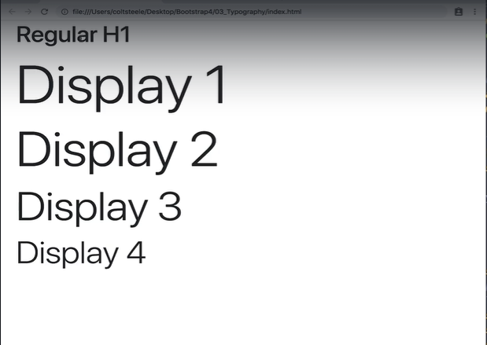

**Blockquotes**

Redesigned blockquotes, moving their styles from the <blockquote> element to a single class called **.blockquote**. **.blockquote-reverse** has been removed.

*<!—Blockquotes 🡪*

*<blockquote>*

*<p class= “mb-0”>Lorem ipsum dolor sit amet, consectetur adispicing elit. Integer posuere erat a ante.</p>*

*</blockquote>*

*<blockquote class= “blockquote”>*

*<p class= “mb-0”>Lorem ipsum dolor sit amet, consectetur adispicing elit. Integer posuere erat a ante.</p>*

*</blockquote>*

*Output:*

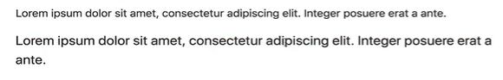

*<blockquote class= “blockquote”>*

*<p class= “mb-0”>Lorem ipsum dolor sit amet, consectetur adispicing elit. Integer posuere erat a ante.</p>*

*<footer class= “blockquote-footer”>Written by my cat<cite title= “Blue Steele”>Blue Steele</cite></footer>*

*</blockquote>*

*Output:*

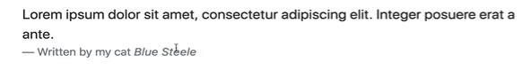

**Pixels (px) to rems**

Bootstrap 3 used pixels (px) as their primary CSS unit but in Bootstrap 4 they switched to rems.

And according to Bootstrap 4,

1rem = 16px

So, Bootstrap takes the size of the root element from the browser which is in pixels (px) and multiplies 16 with it to give the correct font size. In which case, rem is relative to the size of the root element in the browser.